**Human activity recognition based on Decision Trees**

Akshesh Ajitsinh Chavda  
Jithu Joseph  
Bince Thomas  
(University of Kassel)

***Abstract-The smartphone has become an integral part of modern life. Human activity recognition through smartphones provide accurate information than wearable sensors. In this paper, set of human activities data is collected through the smartphone. Features are selected and extracted through sliding window technique and J48 decision tree in WEKA is used to classify and discriminate the activities. The main purpose of this experiment is to compare different decision trees which are trained on single and multiple users. From the result analysis, individual classifier is observed to have better performance than the generalized classifier.***

***Keywords- smartphone, Human activity recognition, Decision tree, WEKA***

# Introduction

Human activity recognition (HAR) is a technique for identifying human activities. Generally, people tend to follow a set of actions in their daily life, such as standing, sitting, walking, running, this activity is detected through sensors that present in the smartphones and classifying the activities.Human activity recognition can be classified in supervised and unsupervised. Human activity recognition is considered as an important tool in various scientific researches.

Human activity recognition is implemented in various domains such as healthcare, human computer interaction, surveillance systems. In healthcare system, HAR is implemented for observing the activities of older people. For an instant, in a rehabilitation centre, people with chronic disease management are observed through HAR. Surveillance system, HAR is implemented for avoiding the crimes and dangers activities in public places like hospitals, banks. Human activity recognition also implementing the human computer interaction field, for full body motion-based games for patients with neurological injury***.***[5]

In this paper, a set of human activity data for walking, standing, sitting, sit-down and stand-up is collected through smartphones. These data are used to classify and differentiate these activities by using J48 decision tree in WEKA. For classifying and differentiating these activities, sliding window technique is used. Features like mean, standard deviation, variance are selected for this task and the dataset is tested through 10-fold cross validation method.

The rest of the paper is organized as, section I, describes related work based on human activity recognition. Section II explains the methodology which includes data processing, plotting of raw data and segmentation algorithm. Whereas, Section III includes the evolution of different decision trees and conclusion.

# state of art

Numerous scientific researches have been done based on Human activity recognition. Human activity recognition, by the help of wearable sensors was one among them. Nowadays, smartphone based human activity recognition is going on. Some of the examples for the HAR by the help of smartphone are; In paper [1], Human activities are collected and classified based on Random forest, J48, SVM and AdaBoost. For this, smartphone sensors collected the data and analysed through time domain wave analysis. 98.82% of accuracy obtained from this task.

In another paper [2], it is focused on activity recognition based on a smartphone for convenient event recommendation. For these six different daily activities are collected and classified with four different classification method including instant-based k-Nearest Neighbour (IBK), decision tree, etc. For reducing the computational load and enhance data management mobile client and cloud server method is introduced. Also, for testing the classification model 10-fold cross validation method is used. Instant-based k-Nearest Neighbour (IBK), produce higher accuracy than other classifiers.

In another paper [3]; it is focused on elder people. Data from acceleration sensor, gyroscope and gravity sensors are collected. Android device is chosen for this task. The collected data are training data and test data. Six different activities are performed by the participants. Multi-layer perceptron (MLP) is used for the classifier training. 94% accuracy obtained from this task. In elder people; sitting, standing, walking, running obtained high accuracy than climbing stairs and going downstairs.

In work [4], data is collected from fifteen participants with different age group varies from 20 to 50. From 2250 samples, ten different features are extracted also, the cross-validation method is performed. Decision tree classifier is implemented for the classification of data. In this paper recognition based on position, vector and behaviour are analysed, from that behaviour recognition obtain high accuracy.

From all different methods mentioned above, we decided to go with Human activity recognition model based on the decision tree method [4]. In our paper, human activities are collected from five participants and classified and discriminating by J48 decision tree in WEKA.

# METHODOLOGY OF ACTIVITY RECOGNITION BASED ON DECISION TREES

## Experimental Setup

Our experiment is carried by smartphones and we developed a lightweight behavioural data collection system. Experiments designed as follows:

1. User information: we received 5 smartphone user’s behaviour data from the department.
2. Activity: behaviour information is collected and categorized into five different activities: standing, walking, sitting, sit-down chair, stand up chair;

## Pre processing

The given data is process of activity labelled with standing, walking, sitting, sit-down chair, stand up chair. These values were noted based on X, Y and Z axes of the accelerometer and gyroscope sensors of the phone. The given raw data is in bulk and so we needed it to reduce without losing the accuracy. For this reason, Segmentation is proposed to separate these raw data. All segments contain acceptable characteristics that allows the human activities. Top-down, bottom-up, and sliding window algorithm is used to time series segmentation. To perform pre-processing, we have divided the data into different segments and each of these segments are examined separately and periodically. In order to perform this, sliding window technique is used. Sliding Window-based segmentation is used to work with data of continuous time series values. The data are segmented into windows and the window slides over the time series [10].

In considering the sequence events, T= {t1, t2, . . ., tn}, where ‘t’ represents the value and ‘tn’ represents nth value of sequence. The time window is represented by ₸ = {tp, tp+1, . . ., t p+w-1}, where w represents size of time window and p represents the arbitrary position [9]. Time window-based segmentation can be done in two ways, they are overlapping and non-overlapping. Here we are using overlapping window. Overlapping window means segments represented by a percentage that defines how many samples from the previous window intersect the samples from the next window. For example, given 200 elements with window size 100 and 50% overlap means that 50 samples from the previous window will be take part in the next window. That is,1 to 100,51 to 150, and 101 to 200 respectively. In the similar way, the Sliding window approach is applied in our paper for five participants, namely P1, P2, P3, P4 and P5.

## Feature Selection and Extraction

Feature Selection is the process where automatically or manually select those features according prediction variable or output [6]. Feature selection is for filtering unnecessary or redundant features from dataset [7]. The difference between feature selection and extraction is that feature selection remains a subset of the original features whereas feature extraction creates fresh ones [7]. Feature extraction from the activity traces establish the training data is performed from matching time windows of 2 seconds [8]. To obtain the information to define the performed activity, a single sample on a specific time instant is not enough. Thus, the time window approach is used in place of a sample basis for recognizing the activities. In order to receive quantitative measures, statistical methods are used to extract features [9]. Mean, Variance, and Standard deviation are the features used.

Mean: Sum all the values in the sample and divide by the number of items [10]

Mean calculated by the equation,

µx = = (1)

Variance: measurement of a spread between numbers in a dataset [11].

Variance is calculated by,

σ2 = $\frac{\sum_{i=1}^{n}{{\left(xi-\overline{x}\right)}^{2}}}{n}$ (2)

Standard deviation: average distance from any point to the mean [10].

Formula for standard deviation is given by,

$σ_{x}=\sqrt{\frac{1}{n}\sum_{i=1}^{n}{x_{1^{1}}^{2}}-\frac{1}{n}{\left(\sum_{i=1}^{n}{x_{i}}\right)}^{2}}$ (3)

## Classifier training and validation strategy

We have trained C4.5 decision tree for human activity recognition. Decision trees use a treelike structure to show decisions [12]. It decides the point value depending on the variable of a new sample based on various attribute values of the available data [13]. It measures the relevance of each feature and uses it to split the elements into homogeneous subsets [13]. The nodes show the condition of the split and the leaf nodes are serving as the decision or the predicted output [12]. The branches or the edges of the tree direct to one of the output variables. Classification and regression problems are used by Decision trees. The J48 Decision tree classifier is used in our experiments. WEKA (Waikato Environment for Knowledge Analysis) tool have inbuilt j48 classifier and it’s written Java.

10-fold cross validation is used for testing dataset. Which means, instances in the data sets are divided into 10 sets. One of these considered as test data and the remaining 9 was used for training the classifier. This process was performed 10 times while repeat the test set over the 10 partitions of the data set [8].

# EVALUATION RESULTS OF ACTIVITY RECOGNITION BASED ON DECISION TREES

In this section, we report detailed results of the performance analysis of J48 classifier. The data obtained from the sensors like accelerometer and gyroscope are pre-processed and then the selected features, mean, standard deviation and variance are calculated. That data is further provided to the classifier for testing of activity behaviour.

The individual dataset of every participant is provided to the classifier and performance is evaluated using 10 cross validation. Table 1 shows the performance of C4.5 decision tree classifier in terms of True positives (TP) rate, False positives (FP) rate, precision, recall rate, F-measure and ROC curve area for each activity.

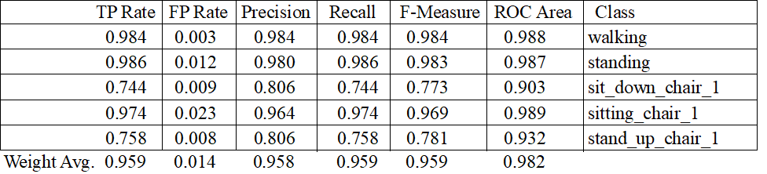

Table 1 Detailed accuracy by class (Participant 1)

Here if we see at the data that is shown in table 1, we can analyse that that F-measure of sit-down chair and stand up chair activity is showing noticeable difference as compared to other activities. The reason behind that is the number of instances for these two activities are very less compared to other activities, as they take place in very short time. Also, the duration of our sliding window is 2s, which is long for determining such short instance activities precisely.

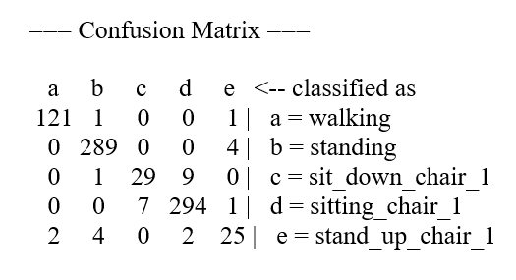

Figure **Error! Use the Home tab to apply 0 to the text that you want to appear here.**.1 Confusion matrix of P1

We can also have a look on confusion matrix shown in figure 1, which represents the number of instances that are correctly predicted and the instances which are wrongly predicted. The column in the confusion matrix represents the actual class and the row is representing the predicted class. The diagonal element in the matrix is representing the correctly classified instances.

The decision tree obtained for participant 1 is shown in figure 2. The total size of the tree is 27, consisting of 13 leaves in it.

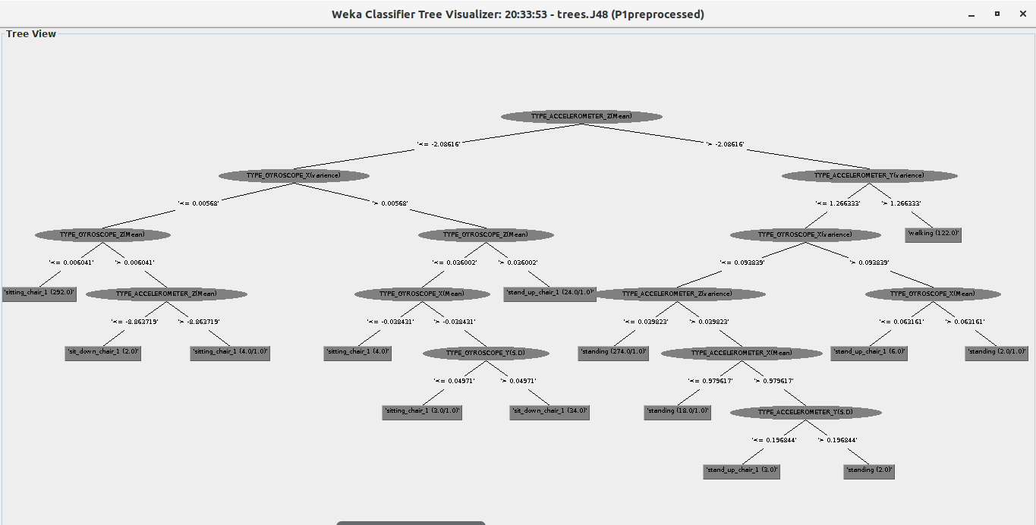

Figure 2 Decision tree of P1

|  |  |  |  |
| --- | --- | --- | --- |
| **Participants** | **Total instances** | **Correctly classified** | **Accuracy (%)** |
| P1 | 790 | 758 | 95.9494 |
| P2 | 547 | 525 | 95.9781 |
| P3 | 711 | 695 | 97.7496 |
| P4 | 806 | 778 | 96.5261 |
| P5 | 753 | 734 | 97.4768 |

Table 2 Accuracy of participants (cross validation)

Similarly, dataset of every participant is provided to the classifier and is tested. The accuracy of individual participant is noted as shown in table 2. It is observed that even if the dataset of all participants is tested in similar manner by classifier, the accuracy is obtained different. It is due to two reasons, firstly, the number of total instances provided to classifier is not same of all participants and secondly, the biological movements and actions of every person is not similar and is varying in nature.

Now, all the individual datasets are accumulated in one file and generalised dataset is prepared for observation of classifier performance on generalised data. True positives (TP) rate, False positives (FP) rate, precision, recall rate, F-measure and ROC curve area of Generalised data is also obtained and it is shown in table 3.

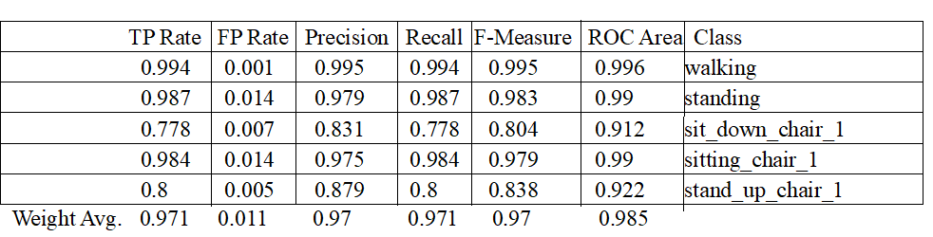

Table 3 Detailed accuracy by class (Generalised)

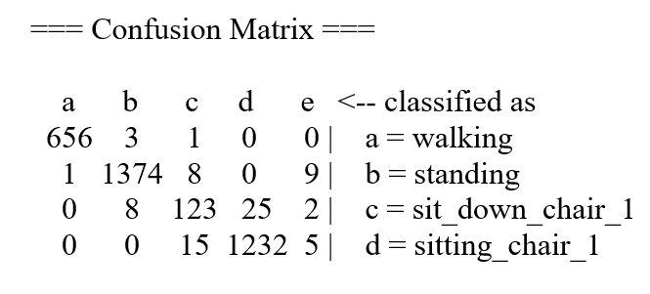

Figure 3 Confusion matrix of Generalised data

Here also it is observed that the results for sit-down chair and stand up chair activity is poor compared to other activities and the reason for that is same as discussed before in individual testing outcomes.

The confusion matrix for generalised data is also obtained as shown in figure 3, which shows how many instances out of total instances are classified correctly and how many are predicted wrong.

Now, this generalised dataset is used for training classifier and test set of P1, P2, P3, P4 and P5 is applied. The output of the generalized classifier on each participant is shown in table 4, and it is clearly visible that results are more precise and accurate compared to the results obtained from cross validation method. The number of correctly classified instances is increased to greater extent. Furthermore, the comparison between generalized classifier and individual classifier trained and tested on individual participant is done in the later portion.

|  |  |  |  |
| --- | --- | --- | --- |
| **Participants** | **Total instances** | **Correctly classified** | **Accuracy (%)** |
| P1 | 790 | 780 | 98.7342 |
| P2 | 547 | 543 | 99.2687 |
| P3 | 711 | 704 | 99.0155 |
| P4 | 806 | 802 | 99.5037 |
| P5 | 753 | 749 | 99.4688 |

Table 4 Output of Generalized classifier

Now, after observing the accuracy of individual and generalised dataset separately it is of interest to know that which feature has best performance in discriminating the human activity efficiently. Data obtained from individual feature is tested in the classifier and accuracy is noted for every participant considering each single feature separately. The result obtained is shown in table 4.

|  |  |  |  |
| --- | --- | --- | --- |
| Participant | Accuracy based on individual feature | | |
| Mean | Standard deviation | Variance |
| P1 | 95.1899 | 84.9367 | 83.6799 |
| P2 | 95.9781 | 86.8373 | 84.4607 |
| P3 | 96.3432 | 80.1688 | 80.5907 |
| P4 | 95.7816 | 90.1985 | 89.9504 |
| P5 | 98.1408 | 89.6414 | 90.1726 |
| Generalised | 95.0374 | 84.2806 | 82.534 |

Table 5 Accuracy based on features

Graph 1 Feature comparision

The output of all the features is compared and it is clearly visible from graph 1 that mean is showing the best performance as compared to standard deviation and variance. So, among mean, standard deviation and variance; mean feature is considered best.

Another thing which is to be analyse is which decision tree is better out of individual and generalised one. For this comparison, firstly, classifier is trained with generalised dataset including data of all participants and is tested with data only of P1, P2, P3 and so on. After that, individual classifier is developed by providing individual dataset to train and test the classifier. The output of comparison between Individual and generalised classifier is depicted in Graph 2 as shown below,

Graph 2 Decision tree comparison

It is clearly visible from graph 2, that the accuracy we are getting from individual trained decision tree is high compared to generalised decision tree and, hence showing better performance.

# CONCLUSION

In this paper, human activity recognition using sensors data, based on Decision trees using J48 classifier is carried out. Five different day to day activities information has been collected based on accelerometer and gyroscope sensor and two kind of activity features are extracted. The decision tree based on these features has been established.

Initially, dataset of participants is pre-processed and sliding window algorithm is applied. Mean, standard deviation and variance are then calculated. It is then applied to J48 classifier and activities such as standing, walking, sitting chair, stand up chair and sit-down chair are identified. We have evaluated generalised decision tree and individual decision tree. It was found that generalized decision tree is bigger in size as compared to individual decision tree because they were having a greater number of instances to be tested. It is found that mean feature is more useful in discriminating the classes compared to other features. Finally, comparing the two different kind of decision trees at last, we have found that individual decision tree classifier can more accurately discriminate the activities as compared to generalised decision tree classifier.

##### References

1. Sarthak Gupta, Ajeet Kumar *“Human Activity Recognition through Smartphone’s Tri-Axial Accelerometer using Time Domain Wave Analysis and Machine Learning”*, “International Journal of Computer Applications (0975-8887) Volume 127-No.18, October 2015
2. Chun-Ting Chen, Wei-Po Lee *“Enabling Human Activity Recognition with Smartphone Sensors in a Mobile Environment”,*” Proceedings of the World Congress on Engineering 2017 Vol 1 WEC 2017, July 5-7,2017, London, U.K.
3. C. D. B. R.-I. C. Robert-Andrei Voicu, "Human Physical Activity Recognition Using," Sensors (Basel), vol. 1, no. 2018, p. 18, 2019
4. Z. W. W. LinFan, *"Human Activity recognition model based decision tree,"* International Conference on Advanced Cloud and Big data, vol. 1, no. 2103, p. 5, 2103.
5. O. C. Ann, "*Human activity recognition: A Overview*," IEEE International Conference on Control System, Computing and Engineering, vol. 1, no. IEEE, p. 5, 2014.
6. R. Shaikh, *"Feature Selection Technique in machine learning with Python,"* To wards the Datascience, p. 5, 28 October 2018
7. B. Wilson, *"Dimensionality Reduction Alogirithms; strength and weakness,"* Elite data science, 2017.
8. M. U. I. Alvina Anjum, *"Activity Recognition Using smartphone sensors,"* First Workshop on People Centric Sensing and communications, vol. 1, no. 2013, p. 6, 2013.
9. K. Wisiol, "*Human-Activity Recognition,"* Graz University of Technology, p. 98, 4 November 2014.
10. J. S.Heinisch, *"Segmentation and Features,"* Communication Technology, p. 96, 4 May 2019.
11. A. Hayes, *"Variance,"* investopedia, New york, 2019.
12. M. Badshah, *"Sensor-Based Human Activity recognition usin smart phone,"* San Jose State University, San Jose,CA, 2019.
13. M. Y. Girija Chetty, *"Intelligent Human Activity Recognition Scheme for health applications,"* Malaysian Journal of Computer Science. vol. 28(1), no. 2105, p. 11, 2015.